Sample title for your contribution to the 37th Forum Bauinformatik in Rostock 2026
Jon Doe¹ and F. D. C. Willard^{1, 2}
¹Chair of AI for Sustainable Construction, University of Rostock, Rostock, Germany
²Chair of Concrete Structures and Infrastructures Engineering, University of Rostock, Germany
E-Mails: jon@doe.de (at least from corresponding author)
Abstract: (length: max. 200 words). Once you your abstract is accepted, you may use ideally the Latex template or alternatively this Word template to hand in your English or German manuscript as a PDF for the full paper submission. The manuscript and the final version must not exceed eight pages including all the figures and references. If you use this Word template, be aware that we plan to insert the final PDF version as-is into the conference proceedings. So please do prepare the final version camera-ready, with figures in the best resolution possible, having figures, tables and citations layouted as described in the following chapter and without dead hyperlinks. Please, consider that we will not accept submissions that do not follow either of the mentioned templates or that manipulated them. To keep all the contributions in the proceedings uniform, please use only the embedded FBI-layout templates (ger: Formatvorlagen) for titles, texts, captions etc. and do not change their properties. If you want to link your ORCID iD, modify the link on the image. We tried to think of everything that is needed to write an interesting and well-illustrated contribution in engineering informatics, if you have any other wishes that are not covered please contact us and we can see whether we can make it possible. We wish you good success with the writing process!
Keywords: Building information modeling (BIM), design automation, algorithms, energy simulation (min. 1 to max. 5)
 | Erschienen in Tagungsband 37. Forum Bauinformatik 2026, Rostock, Deutschland, DOI: will/be/assigned/by/editor  © 2024 Das Copyright für diesen Beitrag liegt bei den Autoren. Verwendung erlaubt unter Creative Commons Lizenz Namensnennung 4.0 International.
- Introduction
  - Introduction subHeading 1
To highlight important phrases or words in a continous text section, you can mark single words fat, italic or underlined.
    - Introduction subSubHeading 1
According to the level of granularity you desire, you can use three levels of hierarchy in the outline of your text.
    - Introduction subSubHeading 2
Please make sure to have at least two headings per hierarchy level.
  - Introduction subHeading 2
If you want to make an enumeration in a text, you can make listings using hyphens:
- You can make a dynamic cross-reference to a heading, e.g. to 1.1.
- You may insert custom pagebreak in word by ctrl + enter to arrange the position of headings.
- To visualize the pagebreaks, activate the visibility of layout operators by typing (control, shift and *).
- Citations
  - Citation style
Please use the IEEE citation style in your contribution. You can cite at the end of a sentence [1], a reference [2] in the beginning of a sentence and multiple sources at once [3, 4]. You can find examples for the most frequent types of references in the references section [1] – [4]. For any further question on IEEE citation styles we refer to offical guidelines.
  - Literature management software
We recommend you to use a professional literature management software. The software allows you to manage many sources, to dynamically update citation style and changes to a document and to migrate references between different projects, via a bibtex export you may also move them to a Latex-Project.
Exemplarily, we refer to Citavi. You may download the free version from here: https://www.citavi.com/de/download, whereas many universities have licences for the full version. To automatically import citations from the web by DOI, you may install the CitaviPicker for your browser, e.g. for Firefox: https://addons.mozilla.org/de/firefox/addon/citavi-picker/
Installing Citavi you automatically install the word add-in, as long as you have installed Microsoft word with a version newer than 2003.
- Figures, tables, algorithms, and formulas
  - Figures
To ensure that your figures are centered and do not exceed the width of the given page layout, you may use a frameless word-table to insert your figures. Use a separate row for the caption.
If you used the built-in functionality of word to enumerate your figures, you can add a dynamic reference in your text, e.g. to Figure 1, as you can do to other sections, e.g. to section 3.2. Be aware that Word distinguishes elements labeled as “figures” (engl.) and as “Abbildungen” (ger.), so that you may need to change your default language to create the desired hyperlinks.

Figure 1: Please add a meaningful caption text below your figure
To create high-quality figures, we recommend you to use professional drawing programs, e.g. Inkscape as shown in Figure 2. Word supports the import of .EMF vector graphics and some SVG-standards. When importing the vector graphics, make sure text is still readable and not reformatted during the import. If you cannot include your figure as a vector graphics, chose a non-compressed format with a high resolution (>300 dpi) and insert it via the foreseen functionality of word. Also here, make sure that everything relevant is readable in your figure.
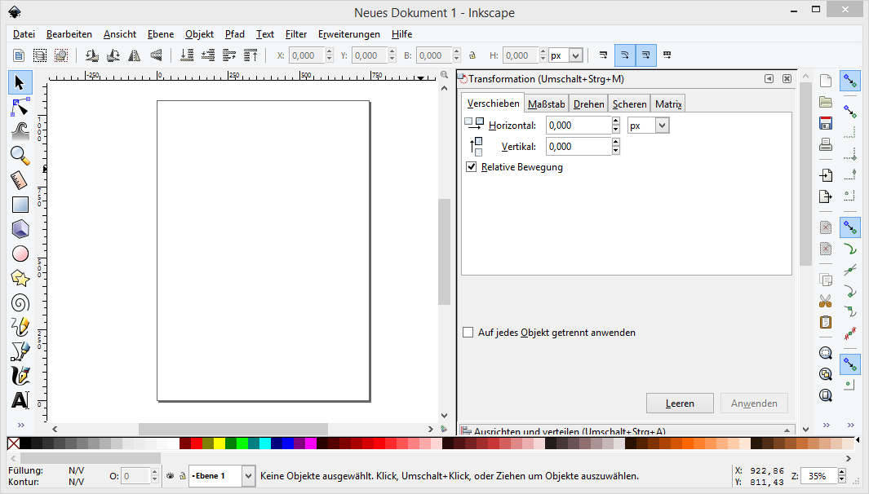
Figure 2: Inkscape as an exemple of a professional drawing program.
  - Tables and algorithms
For very structured information, consider the creation of tables. You may freely use the built- in functionalities and layouts of words and add enumeration and caption above the table, as shown in the example of Table 1:
Table 1: Sample table with three columns and five rows
 | Sample column
Sample row | Sample data

If you want to describe an algorithm, you may either insert it as a figure in the form of a flow chart or sketch it in pseudocode. If you want to insert a pseudocode-based algorithm into word, a solution could be to sketch it in a word table, as shown in the figure below. In this case, you do not need to add a caption as for figures or tables.
Algorithm 1: Sample algorithm
1 | While Condition
2 | Variable Assignment
3 | For Loop
4 | Condition Check
5 | Condition Met: Default Operation
6 | Else: Alternative Operation
7 | End Loop
8 | Break

  - Formulas
If you want to add a formula, please add a frameless table with two colums as shown below. As for figures or labels, you can create dynamic cross-references to the equation, e.g. to Einsteins famous formula (1). Make sure to explain symbols used in your continuous text or by appending a table (without caption) below the equation.
e = mc² | (1)
With the variables defined as follows:
e | Energy [Joule]
m | Mass [kg]
c | Speed of light [m/s]
- Final remarks
Before you hand in your submission in a pdf format, please check the exported document for dead hyperlinks and sufficient resolution of the inserted figures. For language checking, you may use the built-in functionalities of word or more sophisticated add-ons as e.g. Grammarly.
Good success with the writing process. We are happy to welcome you in Rostock this autumn!
Acknowledgements
You can add acknowledgements or funding information in the end of your paper.
References
[1] IEEE Criteria for Class IE Electric Systems, IEEE Standard 308, 1969.
[2] G. Liu, K. Y. Lee, and H. F. Jordan, "TDM and TWDM de Bruijn networks and shufflenets for optical communications," IEEE Trans. Comp., vol. 46, pp. 695-701, June 1997.
[3] Engineers Australia, Cook Islands Renewable Energy, Engineers Australia, Engineering House, Barton, ACT, Australia, July 15, 2015. Accessed on: Oct. 3, 2017. [Online]. Available: https://www.engineersaustralia.org.au/portal/news/cook-islands-renewable-energy
[4] J. O. Williams, “Acoustic analysis of sound,” B.Sc. Thesis, Sch. of Eng. and Appl. Sciences., Harvard Univ., Cambridge, MA, 2013
For further examples, we refer to official guidelines.
Appendix
As long as you do not exceed the total number of eight pages allowed, you may add figures, tables and other information in an appendix section.

